A new, innovative sports coaching apprenticeship aimed at enhancing the lives of

16-24 year olds and the communities in which they serve.

Coach Core Apprenticeship
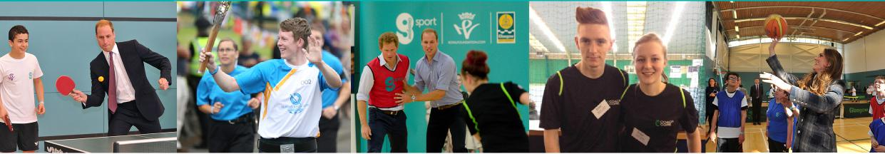
In July 2012, The Royal Foundation launched Coach Core; a new, innovative and exciting sports coaching apprenticeship targeting young people who wish to gain further education and employment in sport. Since then, apprentices in cities across the UK have been able to enjoy an intensive but incredible opportunity to become educated and employed for 12 months with some of the biggest sports providers and clubs in the industry. With a full support team in place, apprentices have thrived both with their professional and personal development as we look to enhance the lives and opportunities for all Coach Core students from the first day to the last.
Successful applicants will be involved in a paid full-time sports coaching training programme to support your development and prepare you for future employment. At the end of the 12 months, you will leave with recognised qualifications, new skills, knowledge and a wealth of experience working as a trainee sports coach plus the opportunity to attend events unique to this programme.
“Coach Core has affected my life for the better; I’ve learned different styles of coaching, gained qualifications and received mentoring to help improve my skills. Before I would sit in the house all day and do nothing but now that I’m on Coach Core I have a chance to get out and be active almost every day of the week acting as a role model in my community to help other people be active.” Jon, Coach Core Trainee, 17.
Coach Core Criteria
To be eligible to apply for the programme, you must:
- Not already be in further education, employment or training.
- Be aged 16 – 24 years old on initial application.
- Be available to participate in 2 day recruitment event on 16th and 17th October 2017
- Provide at least one reference. This can be an individual from your school, college, place of work or sports club.
- Demonstrate an enthusiasm for sport.
- Be available to complete paid employment of 30 hours a week for a full year.
Please note that applicants do not require any formal qualifications to apply for Coach Core.
Our ‘Team Bristol employers are:
Young Bristol Shine Sports Coaching
St Bede’s Catholic College UWE / Wesport
Empire Fighting Chance Youth Moves
Bristol Rovers Community Trust
Creative Youth Network Bristol City Council
Young South West Access Sport

Coach Core Bristol 2017: Recruitment
This year ‘Team Bristol’ will employ 19 young people who have the potential of becoming the future sports coach. We will be inviting applications for 40 places at our 2 day recruitment event on 16th and 17th October 2017. Those who demonstrate commitment and a will to want to better themselves in this sports coaching programme will then be offered year-long employment working and training for 30 hours a week on Coach Core.
Coach Core Benefits
- QUALIFICATIONS! Achieve qualifications and vocational training that matches the criteria required by employers within the sports industry.
- OPPORTUNITY! You will be employed by an exciting and supportive employer but get to engage with other partners to gain even more experiences and opportunities.
- SUPPORT! Mentoring and experience of working alongside professionals from the industry including Sports Development Officers, experienced sports coaches and personnel from National Governing Bodies.
- GROW! Develop personal qualities such as leadership, confidence and responsibility alongside other young people who, like you, want to better themselves and their communities.
- DEVELOP! Practical experience of working in the industry at sports event, in schools, in clubs and coaching within sports venues.
- INSPIRED! The opportunity to attend exciting events and training throughout the apprenticeship

How Do I Apply?
Stage 1
Applicants are required to submit a completed application form, including a statement from the person who is nominating you by Midday 12th October 2017.
Stage 2
Selected applicants will be invited to attend the 2 day recruitment event on 16th and 17th October 2017.
Stage 3
Applicants will then be notified shortly afterwards as to whether or not they have been successful in gaining a place on the programme. Advice and support will be given to unsuccessful candidates.
Stage 4
Successful applicants will begin year-long employment on Coach Core soon after!

More information
If you require any further information about the programme then please contact:

Sarah Casselden
Project Manager,
West of England Sport Trust (Wesport)
Sarah.casselden@wesport.org.uk
01173286254

Application information
Here are some top tips and info if you wish to apply:
- Be completely honest in your application. We will be asking for evidence and will check any information you give.
- Tell us about YOU! This programme wants to give young people an opportunity to succeed so we are looking for leaders, people who love sport and amazing stories NOT who is the smartest or the most qualified.
- The 2 day recruitment day will be mainly practical so be ready to roll up your sleeves and get involved at all times!
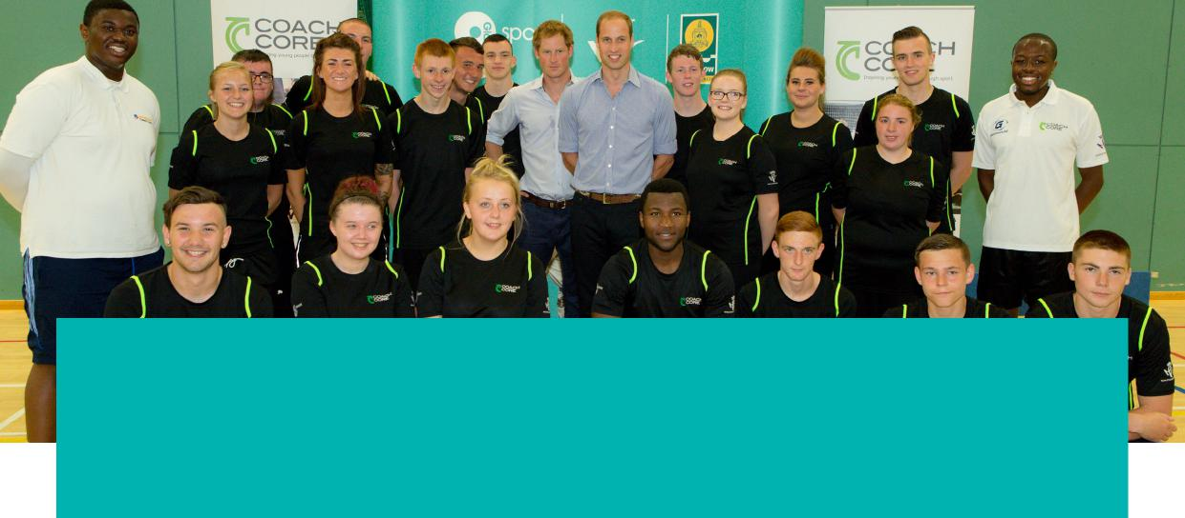

Application form

PART A To be completed by the applicant, please enter all fields. If completing by hand, please feel free to use additional sheets of paper.
Name: | Click here to enter text (first name, surname).
Address: |  | Click here to add text. |  |  |  |  |  |  |  |  |  | Postcode: | Click here.
Date of birth: |  |  | (dd/mm/yyyy) |  | Gender: (please tick one) |  |  |  | Male ☐ Female ☐ I’d rather not say ☐
Telephone (home): |  |  |  | Click here. |  |  |  | Mobile: |  |  | Click here.
Email: | Click here to enter text.
Employment status: (please tick one) |  |  |  |  |  | Student ☐ In employment ☐ currently unemployed ☐
If you are a pupil/student, where are you studying? |  |  |  |  |  |  | Click here to enter text.
If you are a member of a sports club please state the name of the club: |  |  |  |  |  |  |  |  |  |  | Click here to enter text.
Do you consider yourself to have a disability? (please tick one) |  |  |  |  |  |  |  |  |  | Yes ☐ No ☐ I’d rather not say ☐
If Yes, do you require additional support? (please give details)
Click here to enter text.
- Describe what motivates you to be a sports coach on the Coach Core Programme (in 50 - 100 words). Please also tell us about any previous sports coaching experiences and skills you may have.
Click here to enter text.

- What skills do you hope to gain from being part of the Coach Core Programme? (50 words max.)
Click here to enter text.

- Preferred sport: (please list 3 different sports, with the first being your preferred option.)

First choice
Second choice
Third choice
I declare the information I have given is true to the best of my knowledge:
Signature: | Date: dd/mm/yyyy

PART B To be completed by the nominator, please enter all fields.

Please note the nominator must be someone who can provide information for you in a work / voluntary setting, for example, a school teacher or sports club coach.

Applicant name: |  | Click here to enter text (first name, surname).
Nominator name: |  | Click here to enter text (first name, surname).
Nominator address: |  | Click here to add text. |  |  | Postcode: | Click here.
Nominator telephone (home): |  |  | Click here. |  | Mobile: | Click here.
Nominator email: | Click here to enter text.
- How long have you known the applicant? |  |  |  | Years / months.
- In what capacity do you know the applicant?
Click here to enter text.
- Why should the applicant be given this unique opportunity?
Click here to enter text.

I declare the information I have given is true to the best of my knowledge:
Signature: | Date: dd/mm/yyyy

Please note PART A and PART B must be completed before submitting this application.
Deadline for Submitting Application: Midday 12th October 2017.

Please return completed form via email: sarah.casselden@wesport.org.uk

Or via post:
Sarah Casselden
FAO Coach Core
Wesport
c/o UWE, Frenchay Campus
Coldharbour Lane
Bristol
BS16 1QY

