Active Lives: Children and Young People survey
Information for class teachers administering the pupil survey

What is Active Lives?
Sport England run the Active Lives: Children and Young People survey, which measures participation in sport and physical activity among children and young people in Years 1 to 11. The information that we collect will help us to invest in opportunities for children and young people to take part in and benefit from sport and physical activity.
Your school has been randomly selected and has agreed to participate in this survey. At your school, children from up to three classes or tutor groups will be taking part in an online survey at school. This note provides information about this if your class has been selected to take part.
What are we asking you to do?

Your class or tutor group has been randomly selected to complete the survey. This can be completed on a laptop, desktop computer or tablet that has access to the internet. It cannot be completed on mobile phones and we would not recommend that mini tablets are used.
- Your class has been given a unique URL (weblink). Please ensure you use the correct URL for your class. This is particularly important in primary schools where the survey for year 1-2 pupils and the survey for year 3-6 pupils are quite different. Images of the home screens for the different surveys are shown on page 4 (Year 1-2) and page 6 (Year 3-6 and Year 7-11).
- Your pupils should access the survey using the unique URL provided for your class. You may find it helpful to create a shortcut on the desktop for pupils to click on the URL for their particular class, rather than each child having to type it in.
- There is no need for the pupils to log in using a password. If they go to the weblink they will be able to access the survey and get started. For younger pupils you may wish to open the survey using the URL for them or use a shortcut as described above. We recommend that for children in Years 1 and 2, teachers talk the class through the first few screens of the survey – images and comments are provided on pages 4 and 5.
- Pupils should complete the questionnaire (below is some further information about its contents). Once the pupils have completed the survey their answers will be automatically submitted – you do not need to do anything. If a pupil stops part way through the questionnaire, the answers they have given will be submitted but they will not be able to return to the survey to complete it because each time the survey link is used a new questionnaire is started. For this reason, the survey will need to be completed in one sitting.
- For pupils in Years 1 and 2 there is an audio option. When children select the audio icon (headphone symbol) the question will be read out to them. If possible, please provide the pupils with headphones while they complete the survey so they can use this feature.

How many pupils need to complete the questionnaire?
We would ideally like all of the pupils in your class to complete the questionnaire. Pupils can complete the survey at any time so if you would prefer to split the task into more than one session, you can do this.
If one or more pupils miss the main session, it is possible for them to do the survey at a later date. This is particularly important if a group of pupils is absent on the day because of another activity.
Will pupils need help completing the questionnaire?
The survey has been designed for and tested with pupils from the relevant year groups and most pupils should be able to complete the survey without assistance. If there are pupils in the class who usually need help with completing tasks, then it would be useful if this assistance was available to them while they complete the survey.
We have provided you with a test link and a questionnaire guide to assist you in answering any questions that pupils may have.
What will the questionnaire involve?
Each pupil will be asked questions about the sports and activities they have taken part in over the previous week as well as some questions about swimming, physical literacy and wellbeing.

Secondary school pupils who have planners or timetables may find it helpful to have this to hand while they complete the survey.

The survey asks about activities done in the last week. If a pupil was not in school in the last week this does not matter. They will be able to provide information about any activities they did outside of school during this period.

We have provided you with a test link to the survey which will show you the questions that your pupils will be asked and a written guide to the questionnaire. We recommend that you look at this in advance to help you pre-empt any questions your pupils may have when completing the survey.
How long will it take?
The survey is designed to take up to 20 minutes to complete. Pupils who have taken part in lots of activities over the past week may take longer to complete the survey than those who have done few activities. Please prepare for the possibility that some pupils will take longer to complete the survey than others.

As mentioned previously, if a pupil stops part way through the questionnaire, the answers they have given will be submitted but they will not be able to return to the survey because each time the survey link is used a new questionnaire is started. For this reason the survey will need to be completed in one sitting.

What if I can’t access the URLs?
You should have been provided with a test link and a unique link (URL) for your class in advance. You should use the test link to check that your pupils will be able to access the survey. If there are problems with access, please contact your ICT Department to make sure access to the domain has been authorised. Your school has been asked to ensure that the survey domain (and all subdomains) has been ‘whitelisted’ and permitted for use by pupils. The survey domain is *. ipsosinteractive.com
You may click on the unique class URL to check that it works but you should not proceed beyond the first screen as any answers you give will be recorded as if you were a pupil. If you want to see the questions that pupils will be asked, you should use the test link or the questionnaire guide.
Please make sure that when conducting the survey you give pupils the unique URL and not the test URL.
What do I need to tell my pupils?
We have provided you with information sheets for your pupils to explain what the survey is and answer any questions they may have. We recommend that the survey is completed in quiet, exam-like conditions to enable pupils to concentrate and ensure confidentiality.
At the beginning of the session we suggest you highlight the following to the pupils in your class to make sure that they fully understand what they are being asked to do:
- The pupils have been asked by Sport England to complete an important survey called the Active Lives survey about the activity they do.
- There are no right or wrong answers. Sport England wants to know how much activity people do, whether it is a little or a lot.
- The teacher and other staff present can help with reading and understanding the questions but not with answers.
- Pupils should not look at each other’s screens while they are completing the survey. This is to make sure that everyone’s answers remain confidential.
At the end of the survey their answers will be automatically submitted. Pupils should just continue until they get to the final thank you screen.
What should I do if a pupil accidentally closes the survey part way through?
If the pupil is close to the beginning of the survey, they can just enter the URL and start again.
If the pupil has completed the grid questions about which activities they have done in the last 7 days, or has already spent more than 10 minutes on the survey then their answers will have been submitted and they should not start again.
How can I find out more?
We are very grateful for your help with this important research. If you would like any further information about this project, please contact [CSP contact details].

Year 1 and 2 Survey Homepage
Year 1 and 2 children will first be asked to choose between two different characters, a monster and a bird, which will then appear in each of the subsequent questions. Children should touch or click on the image that they would like to choose.
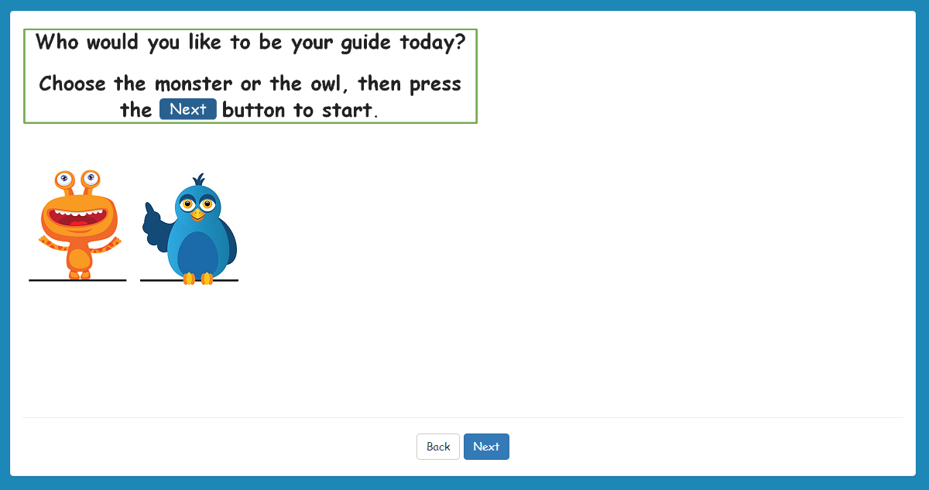
Year 1 and 2 Survey introduction
Year 1 and 2 children will then be shown the following introduction. They do not need to answer a question. Once they have read the instructions they should select the ‘Next’ button. If they wish to change their character, they can select ‘Back’.
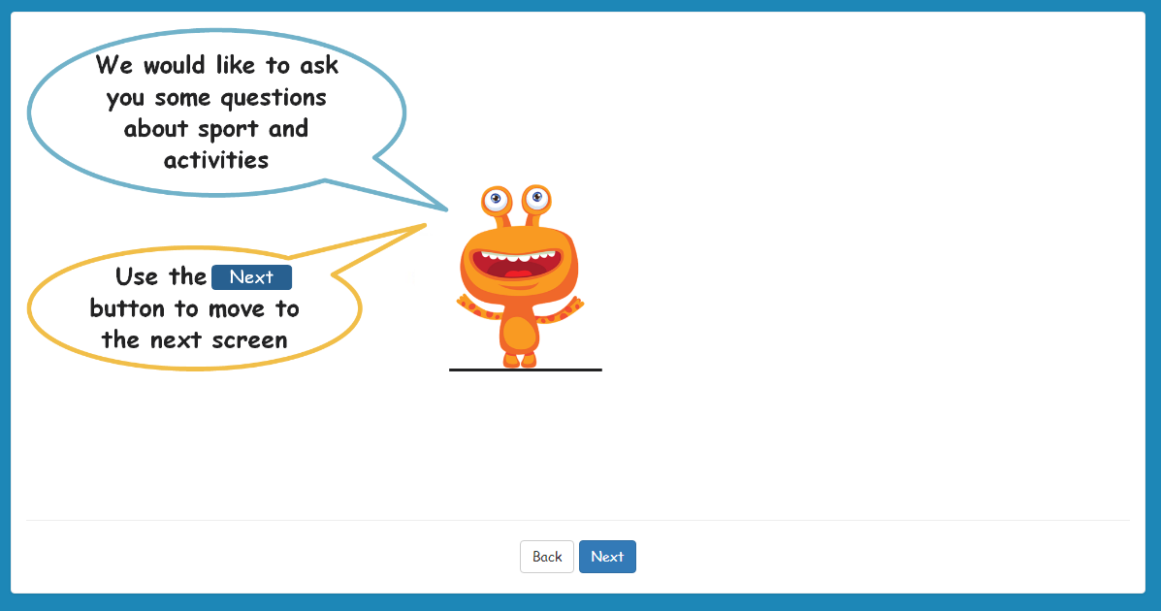
Year 1 and 2 Survey audio instructions
An audio option is available to Year 1 and 2 children. When a child selects the audio icon in the top right-hand corner of the screen (headphone image), the question will be read out to them. If possible, please provide the pupils with headphones while they complete the survey so they can use this feature.
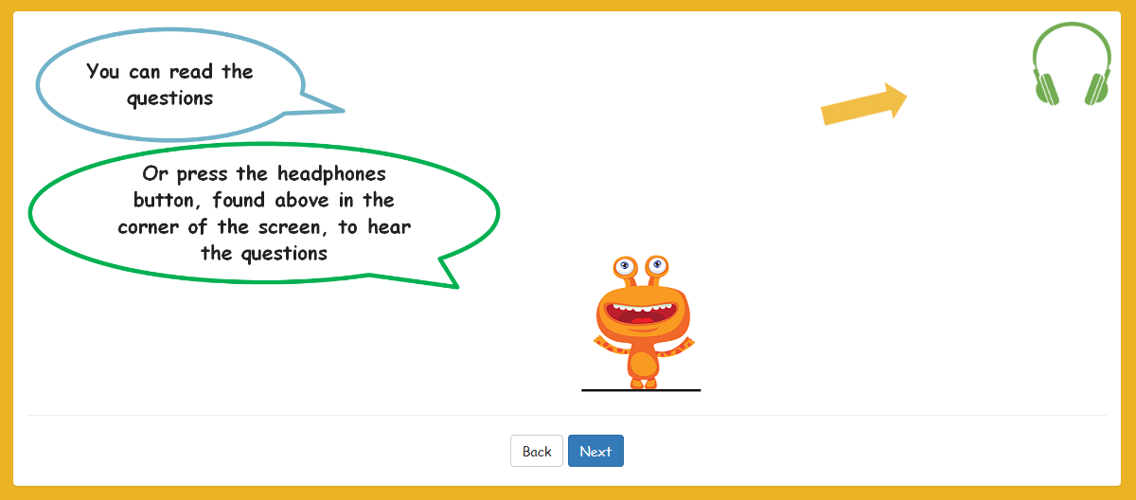
On selecting ‘Next’, children will be taken to the first question of the survey asking them how old they are.
Year 3 to 6 Survey homepage
On entering the URL, Year 3 to 6 children will see the following screen. They should select ‘Next’ to continue.
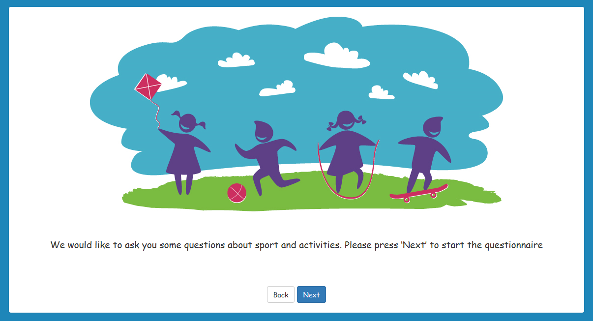

Year 7 to 11 Survey homepage
On entering the URL, young people in Year 7 to 11 will see the following screen. They should select ‘Next’ to continue.
