Together Fund Mapping: Areas of Focus
This document consists of various overlays identifying area where there has been a lack of provision through the previous Tackling Inequalities Fund. Where the mapping has an overlay to demonstrate the population levels within each target audience, the darker the shaded area equates to a larger proportion of people living there that fit within their audience.
Key:
- Culturally Diverse Communities – Green Dots
- Disabled People – Blue Dots
- People with Long Term Health Conditions – Yellow Dots
- Those on Low Incomes – Purple Dots

Bath & North East Somerset
Priority areas as identified by mapping and collaboration with VCFSE Partners:
- Radstock
- Midsomer Norton
- Twerton
- Paulton
Long-term health conditions & disability
- Keynsham South
  - 1173 people whose day-to-day activities are limited
  - No targeted projects ever funded through TIF
- Midsomer Norton Redfield & North
  - 1851 people whose day-to-day activities are limited
  - £2368 spent on Zumba classes for people within this group
- Weston
  - 1010 people whose day-to-day activities are limited
  - No targeted projects ever funded through TIF
- Twerton
  - 1112 people whose day-to-day activities are limited
  - No targeted projects ever funded through TIF
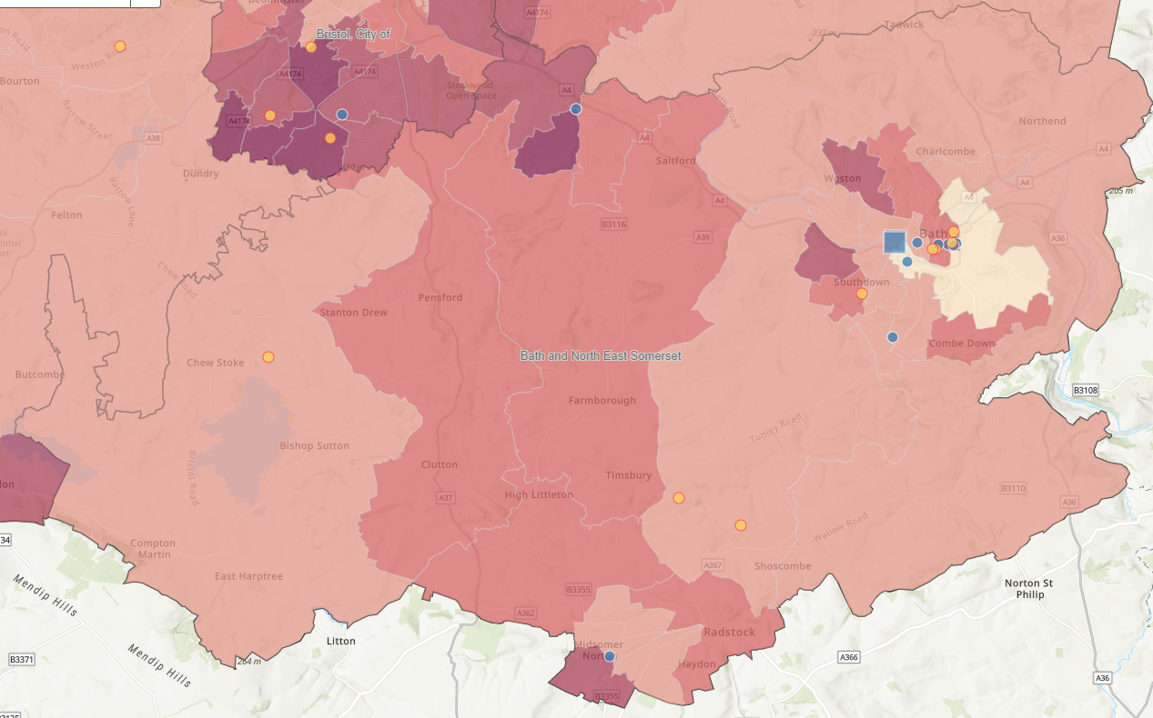
Figure 1: BANES LSEG & LTHC
Low Socio-economic group
- Twerton
  - Area is in the highest NS SeC 6-8 percentage
  - Has 2 sub areas that have a IMD rating of 1, 1 sub area with a rating of 2 and 1 sub area with a rating of 3
  - Throughout delivery period, there has only been 1 TIF project within the area, which was delivered in phase 1
- Radstock, Westfield and Midsomer Norton Redfield
  - Areas are in the 2nd highest NS SeC 6-8 percentage
  - Areas have a total of 4477 impacted people
  - No TIF focused funding
- Keysham South
  - Area is in the 2nd highest NS Sec 6-8 percentage
  - Area has 1160 people impacted people
  - Only 1 previous TIF focused project
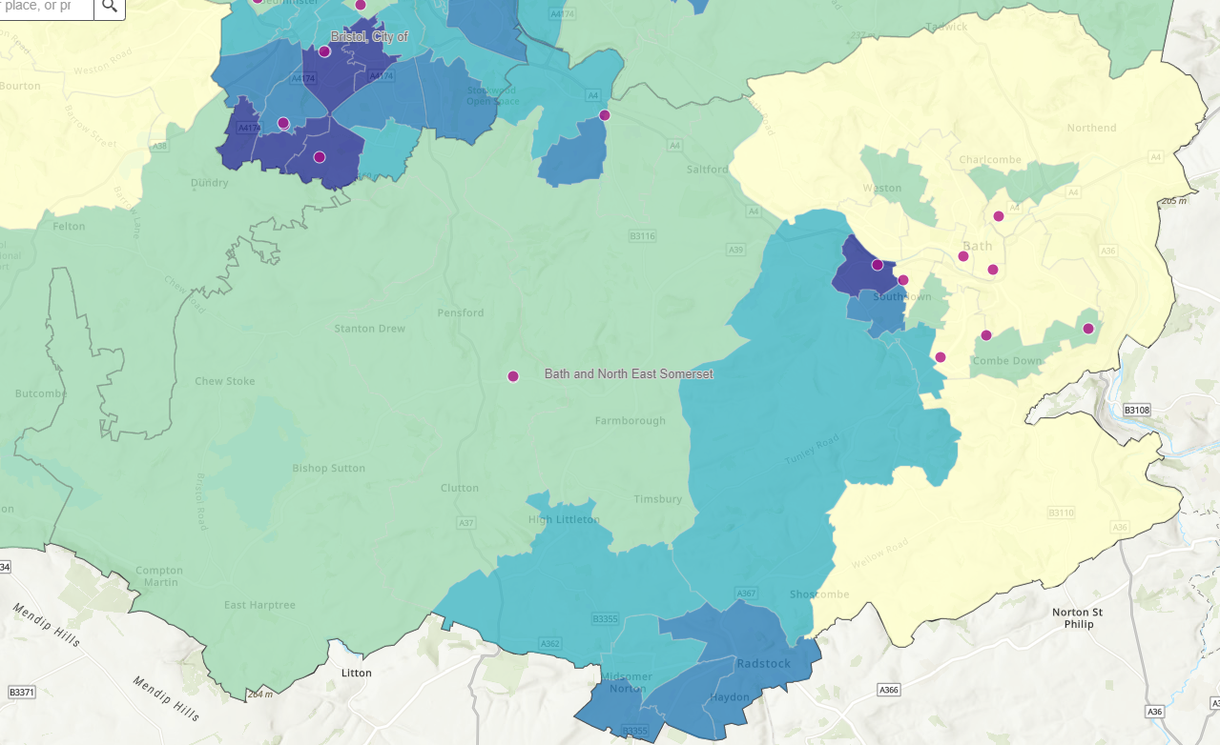
Figure 2: BANES LSEG

Bristol
Priority areas as identified by mapping and collaboration with VCFSE Partners:
- North Bristol: Lockleaze / Lawrence Weston & Avonmouth
- Inner City East: Easton / Barton Hill / Lawrence Hill / St Pauls / St George
- South Bristol: Hartcliffe & Withywood / Knowle & Filwood
Long-term health conditions & disability
- South Bristol (Highridge, Withywood, Hartcliffe & Knowle West)
  - Within the 4 areas, 6,231 people whose day-to-day activities are limited
  - Phase 3, 1 targeted project for long term health conditions funded for £1400 where delivery was focussed in a school
  - There has also only been 1 disability focussed project nearby the focus areas located in Hengrove
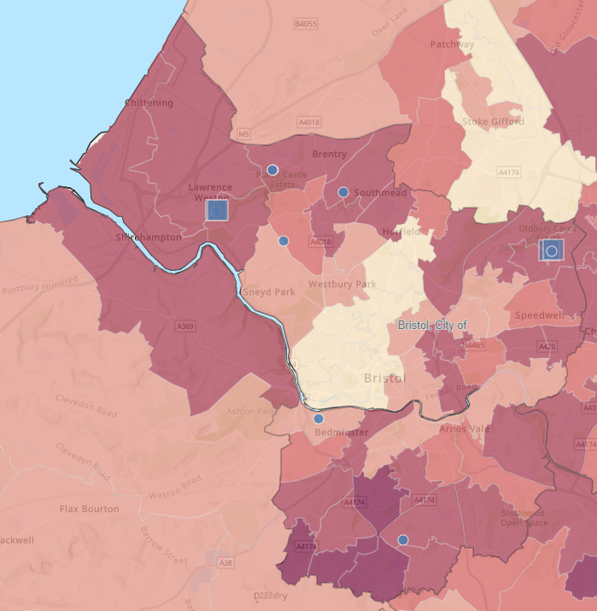
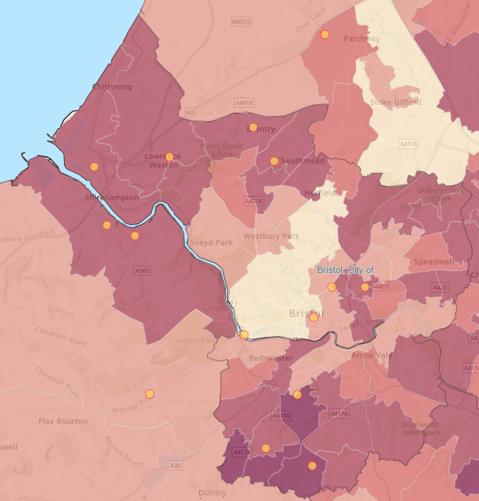
Figure 3: Bristol LTHC Figure 4: Bristol Disabled People
Low Socio-economic group
- Lawrence Weston
  - Whole of Lawrence Weston area is in highest percentage for NS SeC 6-8
  - The specific area highlighted has a IMD rating of 1, the highest of deprivation
  - No specific projects ever funded with the closest being delivered in Southmead
- Shirehampton
  - 2824 people whose day-to-day activities are limited (more 50% of ward population)
  - Not targeted projects through TIF
- South Bristol (Highridge, Withywood, Hartcliffe & Knowle/Knowle West)
  - All areas are in the highest percentage for NS SeC 6-8 and have a IMD rating of 1
  - Over the whole TIF delivery period, there have been a total of 3 projects, 2 in Knowle West, 1 in Hartcliffe
  - 1 in phase 1, 2 in phase 2, with 0 targeted projects delivered in phase 3
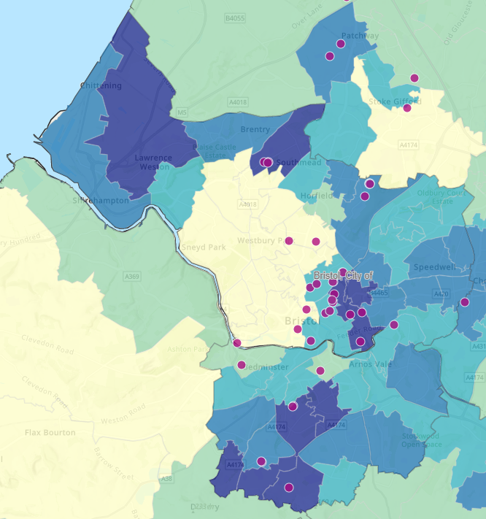
Figure 5: Bristol LSEG

North Somerset
Priority areas as identified by mapping and collaboration with VCFSE Partners:
- Weston – Super – Mare
- Worle
- Winscombe / Hutton
Long-term health conditions & disability
- Weston Super-Mare – In the highest category for Inactivity according to Active Lives Survey, apart from Clarence & hillside
  - Currently 12,151 people whose day-to-day activities are limited
  - £5000 spread across delivery in 7 different care homes with no actual support to external community – Alive Activities Ltd
  - £330 spent on health trackers (smart watches) – British Red Cross
  - No project ever funded targeting specifically for people with a disability
- Winscombe, Langford & Blagdon
  - 1619 people whose day-to-day activities are limited
  - No projects funded within the area ever through TIF (1 project close by for the eastern population of the area)
- Nailsea West
  - 1819 people whose day-to-day activities are limited
  - £330 spent on health trackers (smart watches) – British Red Cross
- Mid Worle
  - 2149 people whose day-to-day activities are limited
  - No projects funded within the area ever through TIF (1 project close by for the eastern population of the area)
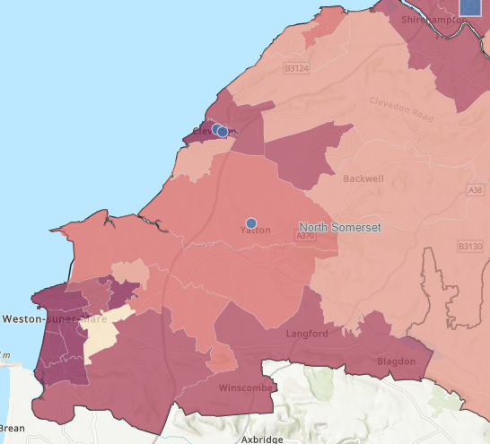
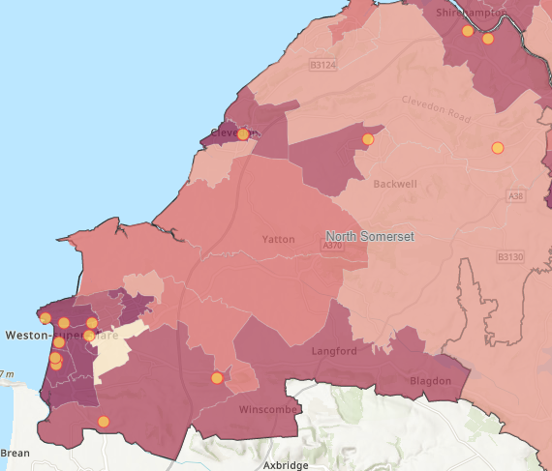
Figure 6: NS LTHC Figure 7: NS Disabled People
Low Socio-economic group
- Weston Town
  - 3004 people in NS-SeC 6-8 with this area being a 1 in IMD
  - No targeted projects in phase 3
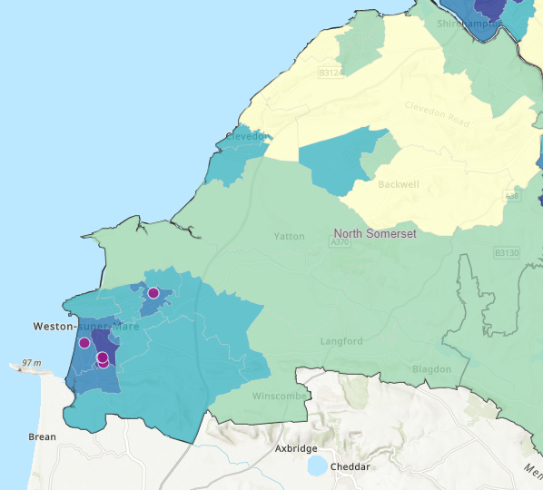
Figure 8: NS LSEG

South Gloucestershire
Priority areas as identified by mapping and collaboration with VCFSE Partners:
- Kingswood
- Staple Hill
- Patchway
- Cadbury Heath
- Yate
- Winterbourne
Long-term health conditions & disability
- Winterbourne
  - 1168 people whose day-to-day activities are limited
  - No targeted projects ever funded through TIF
- Hanham
  - 1555
  - No targeted projects through TIF
- Downend South
  - 1189
  - No targeted projects through TIF
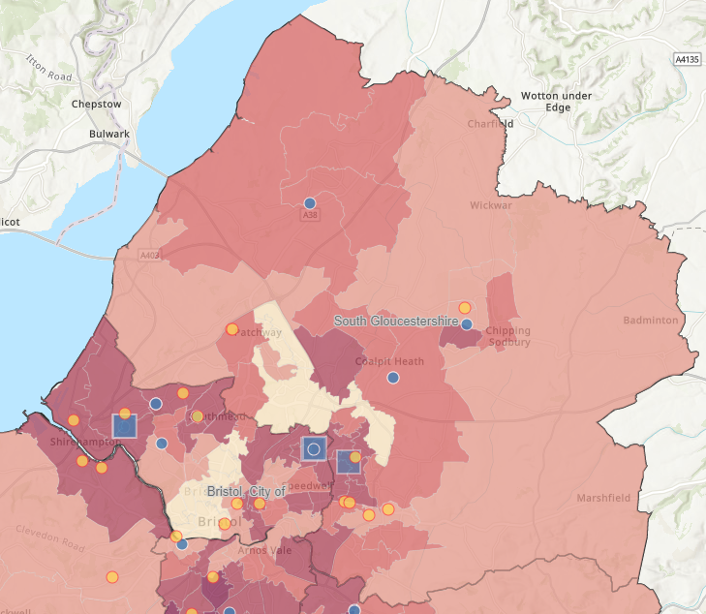
Figure 9: S Glos LTHC & Disabled People
Low Socio-Economic Groups
- Staple Hill South & Kingswood North West, Kingswood North East, Mangotsfield
  - 6067 people whose day-to-day activities are limited
  - No targeted projects through TIF
- Yate West, Yate Kingsgate, Yate South
  - 5479 people whose day-to-day activities are limited
  - No targeted projects funded through TIF
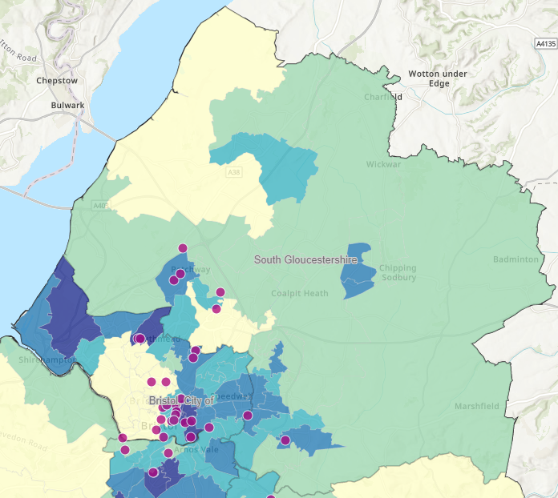
Figure 10: S Glos LSEG

